**Abstract Floral White & Gold Metal Wall Art Decor for Living Room**

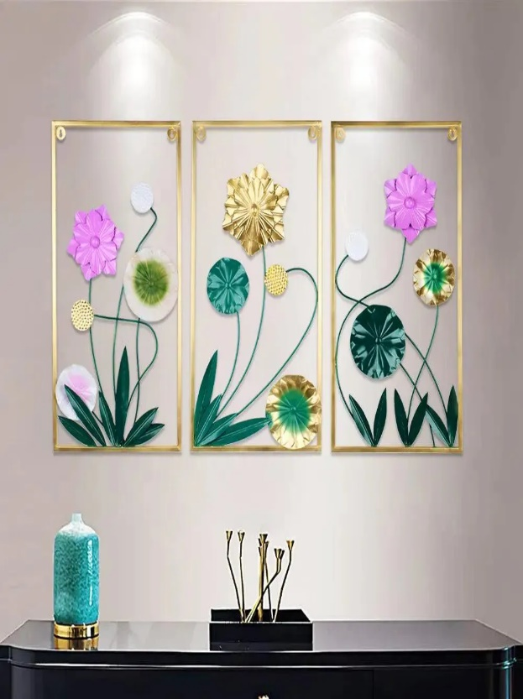Abstract floral white and gold metal wall art decor for the living room is a stunning blend of elegance and contemporary design. The artwork features intricate floral motifs with flowing, abstract shapes, rendered in a striking combination of soft white and radiant gold. The contrast between the subtle white tones and the luxurious gold accents creates a sophisticated, timeless appeal. Perfect for modern or transitional spaces, this metal wall art adds a touch of luxury and serenity to the living room. Its refined design elevates any space, serving as a captivating focal point that enhances the overall aesthetic of the room.